GitHub

# What is GitHub?



GitHub is a Web-based software project repository hosting service. Users may upload and store working software project folder to the service. GitHub facilitates features such as bug-tracking, task and source code management, and wikis for each and every project[git].

GitHub allows for:

1. Version control: users may experiment with code without compromising previous versions of a project folder.
2. Build control: a single project can be accessed on any PC at any single location.
3. Collaboration: one may invite others to operate on a single project folder.

# Getting started

Sign up, then log onto GitHub.

Go to this URL: <https://github.com> [[git1]], and the following page comes up.

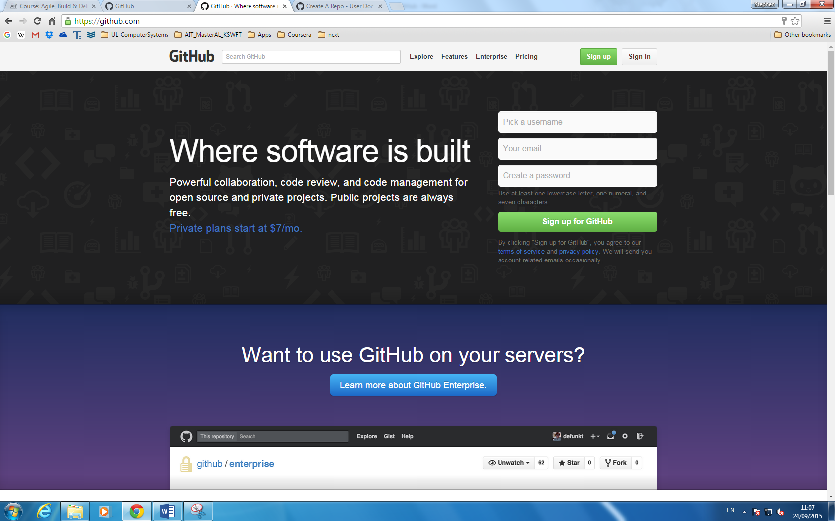

The three components are **username**, **email**, and a **password**. The user can select their own username, and then enter their email account and password. Once signed in, this is what comes up:

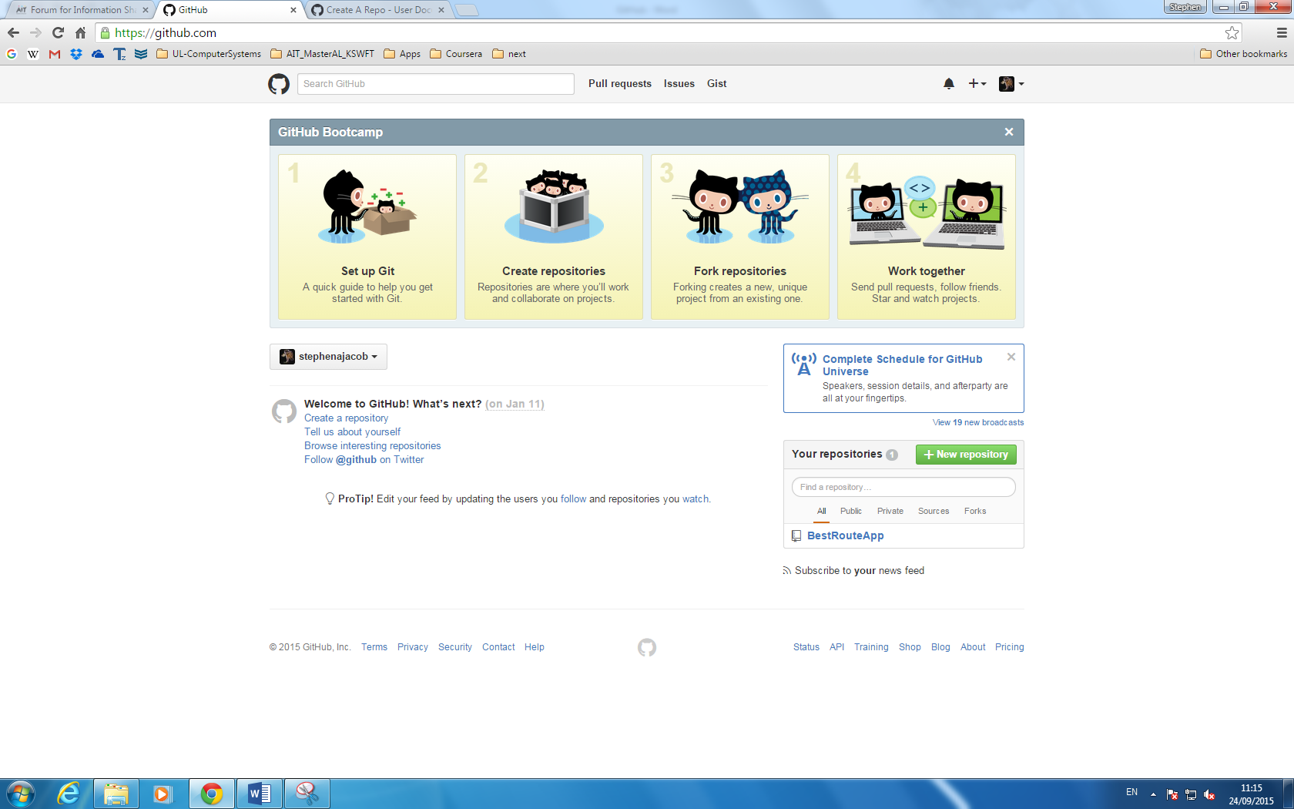

Here we have a close up of the main window labelled *GitHub* *Bootcamp*.

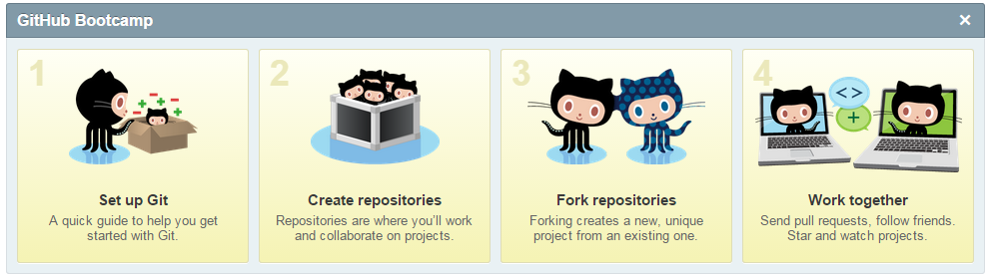

The window “GitHub Bootcamp” labels the four main functionalities of GitHub:

* Getting started on GitHub
* Creating a repository for hosting a private, open-source project
* Forking a repository, creating new projects from existing ones
* Collaborating, sharing projects with other users

## Getting Start with Git on GitHub

For this section Getting Started, the following URL will outline the required steps.

* Download the latest version of Github
* Authenticating on Git using either HTTPS or SSH.

[[git2]]

The most recommended option would be to authenticate using SSH keys. This methodology can identify trustworthy computers. These keys are generated on each computer you use to push or pull from a project.

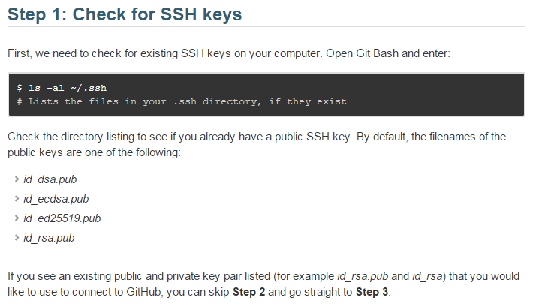

More details on how this can be carried out is found here: https://help.github.com/articles/generating-ssh-keys/

## Creating a Repository

On the GitHub home page there is a window that is exclusive for the user’s use, as displayed and exemplified below:

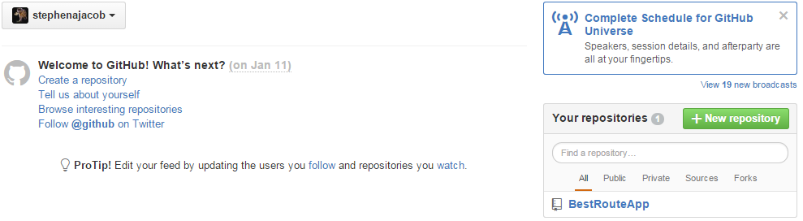

In the top-right hand of the home page there is a ‘+’ sign which when clicked that’s labelled “Create new”, which is used for creating a new repository for the user. The green-outlined words “New repository” can be used for this also. When creating the repository for a particular project, the user must then also declare if the repository is public or private, and commit their changes, updates to the project file.

The details for how this sections is carried out can be found here: https://help.github.com/articles/create-a-repo/

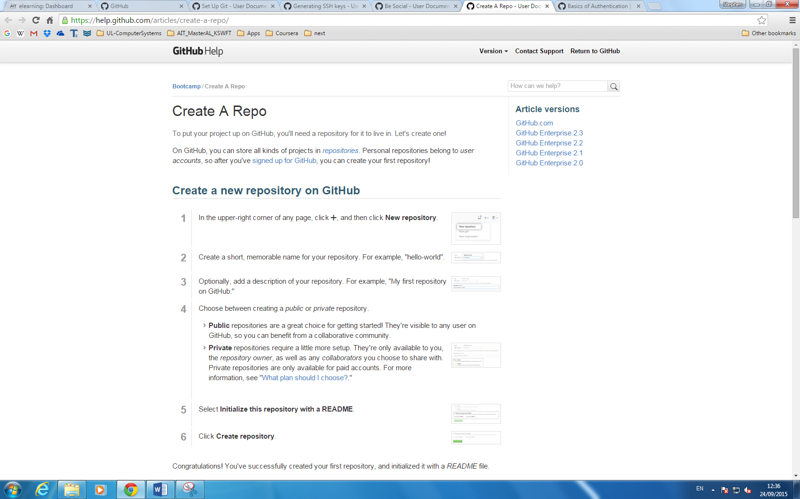

## Forking a repository

The benefits of forking a repository, making a copy, allow a user to experiment on a project without affecting the original source folder. This allows for bug-fixes, recommendations to a user’s source code from others.

One could also use a stored prototype of someone else’s code as a starting point for his own project code.

Full details on the forking option are found here: <https://help.github.com/articles/fork-a-repo/>

An example of forking a sample repository called “Spoon Knife” is illustrated beneath:

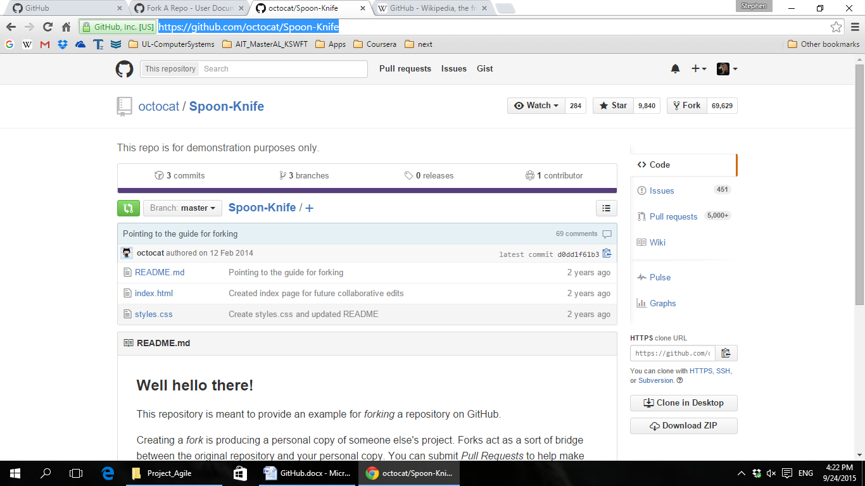

To start a fork, a personal copy of a source code folder, click on the word “Fork” on the right-hand corner.

## Work Together

The final aspect of GitHub is the ability to work with others.

On the home page, when we click the widget “Work Together”, the following URL is what appears.

<https://help.github.com/articles/be-social/>

Benefits inherent in working together allow for people to follow others, they could receive

The following features that centre on collaboration using GitHub are:

* Following other users’ activities, allowing a user to receive notifications of the other’s project
* Watching a project, allowing you to keep up to date with one
* Pull requests in regards to someone else’s project, like how to improve their project, point out something wrong with it
* Invite others to your personal project

The instructions of allowing other users read/write access to a personal repository by adding them as collaborators are listed as follows:

1. Ask the person who wishes to join for their GitHub username.
2. Navigate to the repository’s main page.
3. In the right hand side-bar, go to **Settings**, -> **Collaborators**
4. Type in the usernames, and click on the drop-down menu
5. Click **Add**

## References:

1. [[git]][online][Accessed 24 Sep 2015] WIKIPEDIA
2. [[git1]][online][Accessed 26 Sep 2015] Sign up Git: <https://help.github.com/>.
3. [[git2]][online][Accessed 26 Sep 2015] Get started on Git: <https://help.github.com/articles/set-up-git/>
4. [[git3]][online[Accessed 26 Sep 2015]